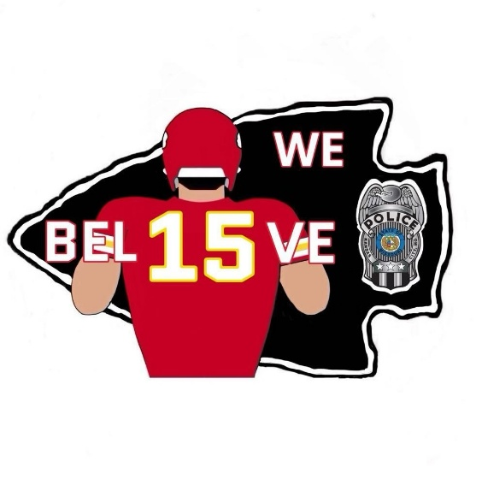
Payment options for BELIEVE coin
PLEASE READ BEFORE MAKING A PAYMENT

Coins are $6 each

Closing sale on April 4th

Please be sure to send your payment via the below listed options, after submitting your order to me via email.

I will respond to each email I receive, verifying your order.
*If you sent me an email and did not receive a response, please email me again.

Please be sure to send your payment after submitting your order via email. If your payment has not been received by April 4, 2025, or if payment arrangements have not been made in advance, your order is subjected to be canceled.

PayPal https://www.paypal.me/BonitaCannon

Cash App $gmapopo09 (zero9)

Venmo @gmapopo09 (zero9) last 4 of cell is 6483

****In the “notes” or “what is this for” section only put BELIEVE

If you are using a business account or something other than your actual name, please put your first and last name in the notes or email me the name of your business. When the name on the payment doesn’t match the name on the order, it makes it difficult for me to figure out who the payment is from. I want to be sure everyone gets the coin(s) they ordered. If someone else is making the payment for you, please have them put your name in the notes.

PayPal: Please pay using friends and family only. If “goods and services” is selected, I will be charged a fee, therefore I will refund the payment made and request that you resubmit your payment.

Venmo: please make sure the full refund choice is off (toggle left and gray in color). If the protection is chosen, I am charged a fee. Unlike PayPal, Venmo does not allow me to refund improperly made payments (because I don’t have a business account). So please send payments correctly.

CASH PAYMENTS
If you choose to pay by cash, please contact me at 816-379-5115 or email bonita.cannon@kcpd.org
before sending. Don’t forget to include your first and last name. Please seal the envelope.

CHECKS
Checks are an acceptable form of payment. Please make the check-out to Bonita Cannon and mail to:

Police Headquarters
Attn: Det. Bonita Cannon
1125 Locust
Kansas City, Missouri 64106

DELIVERY / PICKUP
Coins can be shipped.
Shipping is an additional cost.
1-2 coins is $5
3-5 coins is $7
6 or more coins up to 15 will go in a small flat rate box $11 (if necessary to box them)
Any more than 20 coins will go in a flat rate box for $16 (medium) to $24 (large)

If you want your order shipped, add shipping cost to your order.

Department orders- If you change units/assignments please let me know. Coins will go to the unit in the PD Directory. Pickup is the best option.

Retirees- Please be sure to provide your first and last name with your coin order and with your payment method. Provide your address via email only if you want your coins shipped.

Outside agencies- I will be contacting you via email about delivery once the coins are in.

After payment is made in full to the manufacturer it takes 6-8 weeks to receive the coins. The delay usually occurs when payment for orders are not made on time.

If you have any questions I can be reached via email:
Bonita.cannon@kcpd.org or by phone at 816-379-5115

Thank you,
Bonita

